**Chapter 4 Exercises**

1 a) 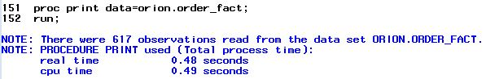

b)

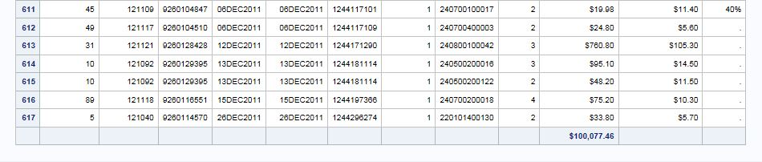

c) 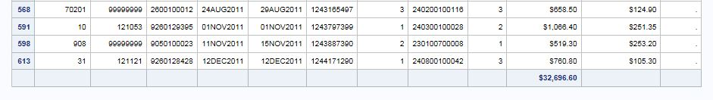

Note that the numbers are not sequential. The original observation numbers are displayed.

The sum of **Total_Retail_Price** changed to reflect only the subset

d) To verify thenumber of observations in the results with the Obs column suppressed,

simply check the log.

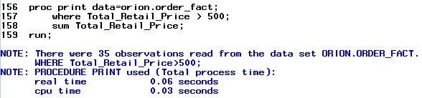

1 e) When the ID statement is added, Customer_ID becomes the leftmost column and is displayed on each line of the observation.

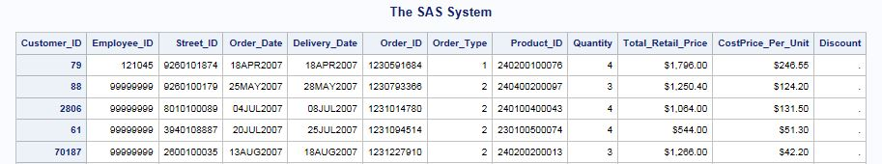

f) When the VAR statement is added there are two Customer_ID columns. The first column is the ID field, and the second one is included because Customer_ID is listed in the VAR statement.

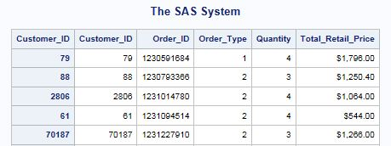

g)

**proc** **print** data=orion.order_fact noobs;

where Total_Retail_Price > **500**;

id Customer_ID;

var Order_ID Order_Type Quantity Total_Retail_Price;

sum Total_Retail_Price;

**run**;

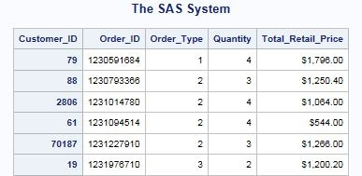

2 a)

**proc** **print** data=orion.customer_dim;

**run**;

b)

**proc** **print** data=orion.customer_dim noobs;

where Customer_Age between **30** and **40**;

**run**;

c)

**proc** **print** data=orion.customer_dim noobs;

where Customer_Age between **30** and **40**;

id Customer_ID;

**run**;

d)

**proc** **print** data=orion.customer_dim noobs;

where Customer_Age between **30** and **40**;

id Customer_ID;

var Customer_Name Customer_Age Customer_Type;

**run**;

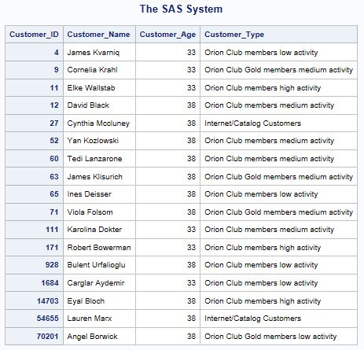

5 a) b)

**proc** **sort** data=orion.employee_payroll out=work.sort_salary;

by salary;

**run**;

**proc** **print** data=work.sort_salary;

**run**;

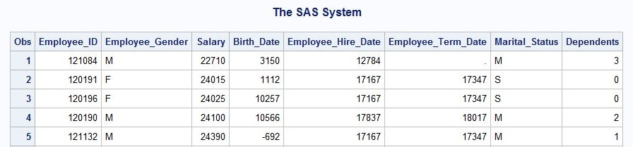



6 a) b)

**proc** **sort** data=orion.employee_payroll out=work.sort_salary2;

by Employee_Gender descending Salary;

**run**;

**proc** **print** data=work.sort_salary2;

by Employee_Gender;

**run**;

**quit**;

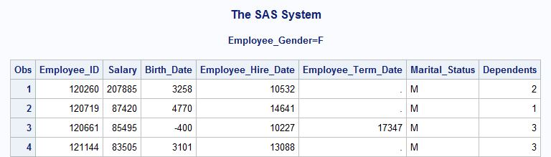

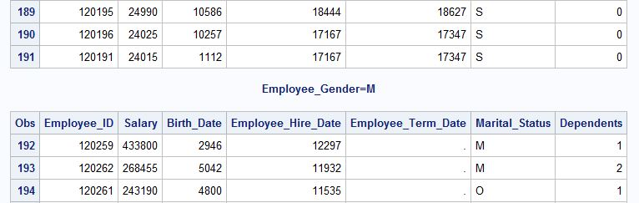

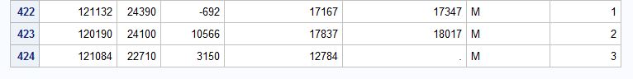

7 a)

**proc** **sort** data=orion.employee_payroll out=work.sort_sal;

by Employee_Gender descending Salary;

**run**;

b)

**proc** **print** data=work.sort_sal noobs;

by Employee_Gender;

sum Salary;

where Employee_Term_Date is missing and Salary > **65000**;

var Employee_ID Salary Marital_Status;

**run**;

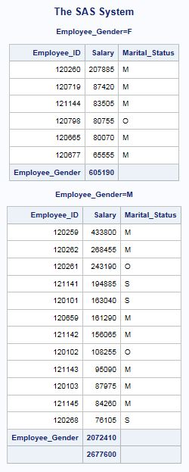

9 a)

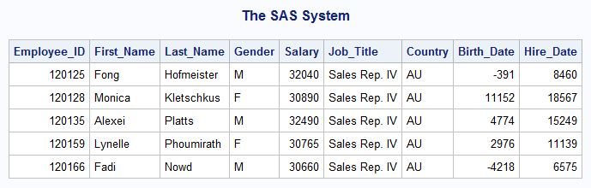

9 b) c) d) e)

title1 'Australian Sales Employees';

title2 'Senior Sales Representatives';

footnote1 'Job_Title: Sales Rep. IV';

**proc** **print** data=orion.sales noobs;

where Country='AU' and Job_Title contains 'Rep. IV';

var Employee_ID First_Name Last_Name Gender Salary;

**run**;

title;

footnote;

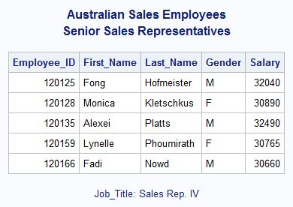

10 a)